Queen’s Baton Relay Batonbearer survey – Headline report

A total of 971 batonbearers responded to the survey request sent out by Glasgow 2014 Ltd on behalf of the Glasgow Commonwealth Games Legacy Research Partnership. Of these, 955 people consented to take part in the survey and completed at least some of the questions. They form the basis of this analysis but as everyone did not complete each individual component of the survey, the base level for each element is provided in the tables.
The headlines
- For most of these involved the experience of being nominated was summed up as ‘being an honour’ (mentioned by 29%), ‘feeling proud’ (34%) and ‘excited’ (17%) with other emotions including delight, pleased, happy and surprised.
- For them, the most positive aspects of being batonbearer were summarised as taking part, family, community, meeting people and being part of the Games – Figure 1.
- The organisation of the QBR and their involvement was viewed positively with the only criticism arising by a small proportion (10%) in relation to the uniform. In contrast the route, security, nomination process and information provided were all viewed as highly satisfactory – Figure 2.
- The Batonbearers were inspired by the experience to consider doing more in their community and to improve the quality of their lives – with nearly half suggesting they would be more involved in their local community and more than half saying they would be more active – Table 1.
- The experience made them proud – more than 85% suggesting that this was a rewarding part of the role. In addition, they felt more connected, knowledgeable and proud of their community – Figure 3.
- Being a batonbearer rewarded them personally – being more confident and more valued – Figure 3.
- The batonbearers felt they were nominated because of their roles in sport (40%), community organisations (16%) and their volunteering (14%) although others were nominated because of their fund-raising efforts, youth work, roles as carers or through personal achievement – Figure 4.

Overall, the survey suggests that as anticipated the QBR batonbearers represent a highly involved group of people connected with their community. The experience was one of which to be proud and honoured and recognition of their contributions to others. Despite this, the experience is likely to increase the levels of involvement by this group, and has encouraged them to become more active.
As a group of highly respected ‘ambassadors’ the survey suggests that the QBR batonbearers may also become important champions for the long term legacy goals of a more active and healthier population.

The positives
For many of those involved with the QBR as batonbearers, the aspects of the experience which were most positive included “being part of the Games or event”, having the oppportuniy to meet people and the be part of the community. However, there was also a strong feeling of pride not only in the role but also in what they did within the community. Many mentioned their appreciation of being recognised and sharing this with their friends and family. As Figure 1 illustrates, recurring words in the list of ‘three main positives’ include these dimensions as well as connections with school, sport and others.
Figure 1 : the three most positive aspects of being a batonbearer
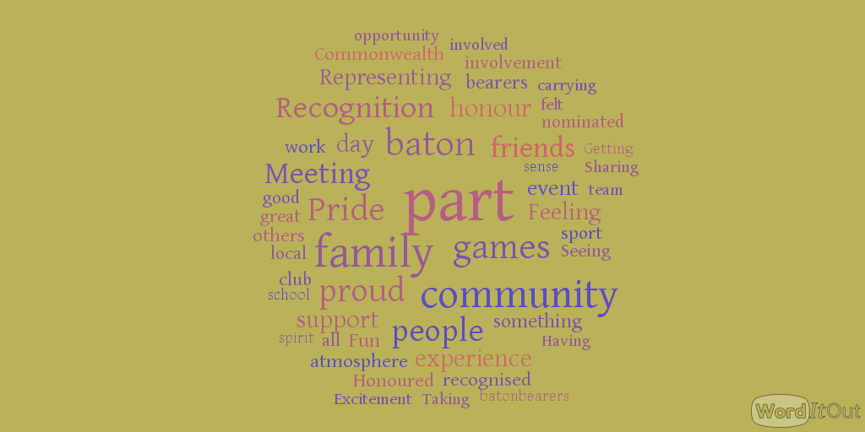

Their experience of the role
Unsurprsingly given the overall positive feelings of their role – with 65% finding their role rewarding for themselves – there was a high degree of satisfaction with the overall experience. Less than 2% found most of the elements of the organisation listed in Figure 2 less than satisfactory with most criticism relating to the QBR uniform. Dissatisfaction rose to 10% on this element, with only just 50% very satisfied.
Figure 2: degress of satisfaction with the experience

The impact of being a batonbearer
A key element of this research was to explore how the batonbearer felt about themselves and the relationship with their community as a result of being nominated and participating in the QBR. Above all else (Figure 3) was their sense of pride in being a batonbearer with over 85% indicating thas a very rewarding aspect of the role. However being invovled also increased their confidence – 70% indicating this as rewarding – and a similar proportion being more valued, although it is noticeable that only 17% thought this was very rewarding.
In relation to their connectivity with their local community, many found this to be a rewarding component, with greater pride in the community, more connections with and knowing more about their community all being part of the benefits and impact of the experience.
Figure 3 Rewarding impacts of being a batonbeater

Being inpsired….
The experience of being invovled in the QBR had a positive impact on most of those involved. Despite their already heavy commitment to volunteering in communities or involvement in sport and communtiy organisations, many of the batonbearers were inspired to do more and to reflect on the key legacy message of the Games to be more active and healthy.
As Table 1 shows, more than half of the respondents suggested they were planning to be more involved in their local community and 2 in 4 would volunteer within that community. Given the high proportion of bearers already invovled with sport, it was less suprising to see 1 in 4 suggesting they were inclined to use sports facilities.

Table 1 : the inspiration effect of being a batonbearer
Answer | Response | %
Within the community
be more involved in local community | 267 | 46%
volunteer in local community | 229 | 39%
volunteer in sports clubs | 159 | 27%
engage with cultural events | 152 | 26%
use sports facilities | 145 | 25%
On a personal basis
be more active | 298 | 51%
walk more often | 192 | 33%
participate in sport | 174 | 30%
change to healthier lifestyle | 158 | 27%
cycle more often | 99 | 17%
use public transport | 77 | 13%

However the inspiration of the QBR was not only in relation to others but also a moment to reflect on their own personal wellbeing. Half of those responded intended to be more active as a result of the experience, with many likely to walk more often or participate in sport. One in six indicated they were likely to cycle more often.

Being nominated
As noted above for most of the respondents, being asked to be a batonbearer was an honour, privilege and a recognition of their roles within communities, in sports clubs and groups, and in their volunteering. Whilst for some they were unsure or did not know about why they had been nomiated or who had nominated, them for most respondents they were able to explain why they had been nominated and by whom.
As would be expected given the guidelines issued in the nomination process and in the selection process underaken by Commonwealth Games Scotland and Glasgow 2014 Ltd, conenctions with sport, communities and volunteering dominated the individual reasons provided by the respondents. Categorising the 855 batonbearer into groups, Figure 4 indictaes that just over 40% felt their nomination was because of connections and involvement with sport – either through a formal organisation or by their role in relation to sporting activity. Approximately 1 in 6 indicated that their role in the community or in volunteering more generally was the reason for their nomiation, with less than 5% pointing to other resasons.

Figure 4: the reasons for nomination

And for most of the batonbearers they also knew who had nominated them with most being put forward either by the local club or community organisation of by a member of the family (Figure 5).
Figure 5: The nominees

Figures 4 and 5 are significant as they reinforce the assertion that batonbearers had a strong existing connection to their communities. With most nominated on this basis, it is unsurprising that this group represents a highly active and committed cohort in Scotland. In this context, therefore, the results of this survey which points to this group using the experience of the QBR as an opportunity to reflect on these connections and conclude that they can be more involved within their communities is noteworthy. Similarly, the reflection on their own personal wellbeing and activity is an important point as it shows this group being inspired through the QBR experience to be more active and more engaged with walking, cycling and sport.
As a group of highly respected ‘ambassadors’ the survey suggests that the QBR batonbearers may also become important champions for the long term legacy goals of a more active and healthier population.

Who were they?
Of the 827 who indicated, 4 were from outside of the UK and 96% were from Scotland, with 16% from Glasgow. 11% of those who indicated considered themselves to have a disability. They were split almost evenly between male and female although there were 4% more females in the sample.
The survey respondents were split across these different age groups:
Answer | Response | %
16-19 years | 123 | 15%
20-24 years | 40 | 5%
25-34 years | 68 | 8%
35-44 years | 98 | 12%
45-54 years | 175 | 21%
55-64 years | 166 | 20%
65+ years | 133 | 16%
Prefer not to say | 13 | 2%
Total | 816 | 100%

They came from all the 32 local councils in Scotland and equally carried the baton across all the council areas. There was as to be expected, given the domestic route of the QBR, largest numbers from Glasgow and carrying the baton in the city.
Question | Authority in which I live` | Authority in which I carried the Baton
Aberdeen | 24 | 29
Aberdeenshire | 37 | 31
Angus | 19 | 22
Argyll and Bute | 27 | 27
Clackmannanshire | 21 | 23
Dumfries and Galloway | 20 | 23
Dundee | 17 | 19
East Ayrshire | 20 | 23
East Dunbartonshire | 30 | 17
East Lothian | 22 | 27
East Renfrewshire | 22 | 23
Edinburgh | 25 | 25
Falkirk | 22 | 23
Fife | 26 | 24
Glasgow | 68 | 84
Highland | 18 | 16
Inverclyde | 17 | 18
Midlothian | 24 | 31
Moray | 26 | 31
Na h-Eileanan Siar | 20 | 23
North Ayrshire | 32 | 30
North Lanarkshire | 21 | 17
Orkney | 17 | 18
Perth and Kinross | 16 | 12
Renfrewshire | 41 | 39
Scottish Borders | 35 | 33
Shetland | 20 | 19
South Ayrshire | 15 | 15
South Lanarkshire | 26 | 22
Stirling | 22 | 22
West Dunbartonshire | 29 | 33
West Lothian | 23 | 23

Further Research
Our primary research interest regarding the QBR relates to investigating the potential for a meaningful community legacy for communities across Scotland. We are concerned with identifying whether or not this often symbolic and short-term event has the potential to have a noticeable effect on community networks and social capital through conducting further research into the specifics of the batonbearer experience. The responses to Question 17 (displayed in Table 1) show the first signposts toward an extension of the benefits beyond the short-term. The indication that 46% of batonbearers felt inspired to be more involved in their local community and that 39% were inspired to take up a volunteering role prompted us to explore the specifics of these claims through further research. Initially, the planned course of action was to undertake ~30 telephone interviews with a representative sample of bearers. We decided however, that the large body of respondents who showed interest in further involvement (420) could be utilised to its full potential through a second online survey with a tighter focus on the 6 months after the QBR. The survey features only 4 questions yet each allows for far greater levels of expression in order for the respondent to put forward their experience in their own words.
- ‘How has your local community reacted to you being a batonbearer? Has this continued since the Games?’
- ‘In what ways has your role as a batonbearer changed the ways in which you are involved with your local community? (e.g. Has it increased or altered the roles you have?)’
- ‘Has your role as a batonbearer influenced the ways in which your friends and family have engaged with the community? If so, tell us how this has altered?’
- ‘How do YOU feel NOW having been a batonbearer last summer at the Commonwealth Games? Has it changed you? In what ways?’
In asking these questions, we hope to investigate the realisation of the greater levels of community involvement projected by the initial survey, and identify whether the Queen’s Baton Relay has the potential to be more than a short-term symbolic event, with tangible legacy benefits for communities.

